
Taller Pre bimestral

Name: ___________________________________________________________________
Grade: Fourth Date: _______________________

Review of the topics.
- Match the words with the pictures.

- Library: "I like to read books at the library."

- Grocery Store: "We buy food at the grocery store."

- Park: "I play with my friends at the park."



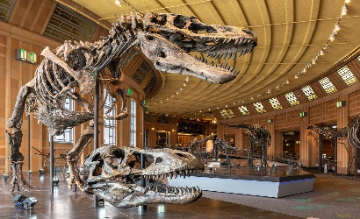
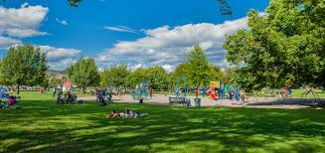
- Museum: "I see interesting things at the museum."

______ ________ ______ _______
- Look for these words and write them in Spanish
Dirty:
Noisy:
Clean:
Eco-friendly:
Busy:
Crowded:
Hot:
Dry:
Buildings:
Green city:
Billboards:
Solar panels:
Paintings:
Lights:
Parks
Full of:
Cars:
Trash:
Travel:
People:
Car:
Bus:
Bicycle:
Train:
Boring:
Exciting:
Quiet:
Slow:

Dull:
Fast:

Fun:

Empty:

Dangerous:
Sad:

Tired:
Happy:
Angry:

